BANK LOAN REPORT QUERY DOCUMENT

The main purupose of Sql queries execution is for the confirmation of data that is visualized and analysed using tableau matches with exact count or the data we have been provided. Tableau and power bi are garbage in and garbage out.

**Implemented SQL queries to ensure data accuracy, reliability and consistency in the dashboards**.

Unleashing Loan Insights: A Data Analyst's Deep Dive into Bank Performance  
I'm thrilled to share my recent data analytics project focused on bank loan analysis. Leveraging SQL's robust functionalities, I delved into the world of loan applications, funded amounts, repayments, and borrower profiles to extract valuable insights for informed decision-making.  
  
Key Performance Indicators (KPIs) Uncovered:  
  
Loan Application Dynamics: I calculated the total loan applications, tracked month-to-date (MTD) trends, and analyzed month-over-month (MoM) changes to understand loan demand fluctuations.  
Funding Efficiency: I explored the total funded amount, monitored MTD disbursement, and analyzed MoM variations to assess loan approval and funding effectiveness.  
Repayment Performance: I tracked the total amount received, analyzed MTD repayments, and assessed MoM trends to evaluate borrower behavior and bank cash flow health.  
Portfolio Cost Analysis: I calculated the average interest rate across all loans, analyzed MTD interest rates, and monitored MoM variations to gain insights into the overall cost of the lending portfolio.  
Borrower Risk Assessment: I calculated the average debt-to-income (DTI) ratio for all loans, analyzed MTD DTI, and tracked MoM changes to understand borrower financial health and creditworthiness.  
SQL Skills Highlighted:  
  
Database & Table Creation  
Data Manipulation: SELECT, DATENAME, DATEPART, CAST, DECIMAL, MONTH, HOUR, QUARTER, DAY  
Data Aggregation: GROUP BY, ORDER BY, COUNT, DISTINCT  
Advanced Techniques: CTE, PARTITION  
Impact & Future Exploration:  
  
This project empowered the bank to gain a deeper understanding of loan application patterns, borrower risk profiles, and overall lending portfolio performance. These insights can be used for optimizing loan approval processes, pricing strategies, and risk management initiatives.  
  
Going forward, I'm eager to explore predictive modeling techniques to forecast loan demand, identify potential defaults, and ultimately enhance the bank's lending efficiency and profitability.

A. BANK LOAN REPORT | SUMMARY

KPI’S:

Total Loan Applications:

select count(id) as Total_loan_applications from bank_loan_data



Month to Date(MTD) Loan applications:

select count(id) as MTD_Total_loan_applications from bank_loan_data

where month(issue_date) = 12 and year(issue_date) = 2021



Previous month to date(PMTD) Loan Applications:

select count(id) as PMTD_Total_loan_applications from bank_loan_data

where month(issue_date) = 11



Total funded amount:

select sum(loan_amount) as Total_funded_amount from bank_loan_data



MTD funded amount:

select sum(loan_amount) as MTD_Total_funded_amount from bank_loan_data

where month(issue_date) = 12 and year(issue_date) = 2021



PMTD funded amount:

select sum(loan_amount) as MTD_Total_funded_amount from bank_loan_data

where month(issue_date) = 11 and year(issue_date) = 2021



Total Amount Received:

SELECT SUM(total_payment) AS Total_Amount_Collected FROM bank_loan_data



MTD Total Amount Received:

SELECT SUM(total_payment) AS Total_Amount_Collected FROM bank_loan_data

WHERE MONTH(issue_date) = 12



PMTD Total Amount Received:

SELECT SUM(total_payment) AS Total_Amount_Collected FROM bank_loan_data

WHERE MONTH(issue_date) = 11



Average Interest rate:

select round(avg(int_rate),4) * 100 as Average_interest_rate from bank_loan_data



MTD Average Interest rate:

select round(avg(int_rate),4) * 100 as MTD_Average_interest_rate from bank_loan_data

where month(issue_date) = 12 and year(issue_date) = 2021



PMTD Average Interest rate:

select round(avg(int_rate),4) * 100 as PMTD_Average_interest_rate from bank_loan_data

where month(issue_date) = 11 and year



Average Debt_to_Income Ratio(DTI):

select round(avg(dti),4) *100 as Average_dti from bank_loan_data



MTD Average DTI:

select round(avg(dti),4) * 100 as MTD_Average_dti from bank_loan_data

where month(issue_date) = 12 and year(issue_date) = 2021



PMTD average DTI:

select round(avg(dti),4) * 100 as PMTD_Average_dti from bank_loan_data

where month(issue_date) = 11 and year(issue_date) = 2021



**GOOD LOAN ISSUED:**

Good Loan Percentage:

SELECT

(COUNT(CASE WHEN loan_status = 'Fully Paid' OR loan_status = 'Current' THEN id END) * 100.0)

/

COUNT(id) AS Good_Loan_Percentage

FROM bank_loan_data



Good Loan Applications

SELECT COUNT(id) AS Good_Loan_Applications FROM bank_loan_data

WHERE loan_status = 'Fully Paid' OR loan_status = 'Current'



Good Loan Funded Amount

SELECT SUM(loan_amount) AS Good_Loan_Funded_amount FROM bank_loan_data

WHERE loan_status = 'Fully Paid' OR loan_status = 'Current'



Good Loan Amount Received

SELECT SUM(total_payment) AS Good_Loan_amount_received FROM bank_loan_data

WHERE loan_status = 'Fully Paid' OR loan_status = 'Current'



**BAD LOAN ISSUED**

Bad Loan Percentage

SELECT

(COUNT(CASE WHEN loan_status = 'Charged Off' THEN id END) * 100.0) /

COUNT(id) AS Bad_Loan_Percentage

FROM bank_loan_data



Bad Loan Applications

SELECT COUNT(id) AS Bad_Loan_Applications FROM bank_loan_data

WHERE loan_status = 'Charged Off'



Bad Loan Funded Amount

SELECT SUM(loan_amount) AS Bad_Loan_Funded_amount FROM bank_loan_data

WHERE loan_status = 'Charged Off'



Bad Loan Amount Received

SELECT SUM(total_payment) AS Bad_Loan_amount_received FROM bank_loan_data

WHERE loan_status = 'Charged Off'



**LOAN STATUS**

SELECT

loan_status,

COUNT(id) AS LoanCount,

SUM(total_payment) AS Total_Amount_Received,

SUM(loan_amount) AS Total_Funded_Amount,

AVG(int_rate * 100) AS Interest_Rate,

AVG(dti * 100) AS DTI

FROM

bank_loan_data

GROUP BY

loan_status

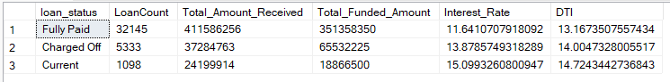

SELECT

loan_status,

SUM(total_payment) AS MTD_Total_Amount_Received,

SUM(loan_amount) AS MTD_Total_Funded_Amount

FROM bank_loan_data

WHERE MONTH(issue_date) = 12

GROUP BY loan_status

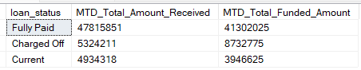

B. BANK LOAN REPORT | OVERVIEW

**MONTH**

SELECT

MONTH(issue_date) AS Month_Munber,

DATENAME(MONTH, issue_date) AS Month_name,

COUNT(id) AS Total_Loan_Applications,

SUM(loan_amount) AS Total_Funded_Amount,

SUM(total_payment) AS Total_Amount_Received

FROM bank_loan_data

GROUP BY MONTH(issue_date), DATENAME(MONTH, issue_date)

ORDER BY MONTH(issue_date)

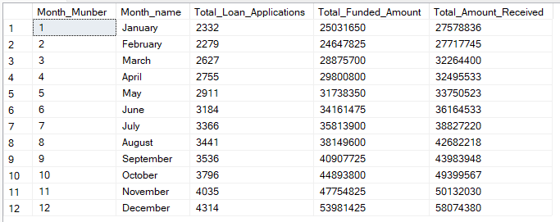

**STATE**

SELECT

address_state AS State,

COUNT(id) AS Total_Loan_Applications,

SUM(loan_amount) AS Total_Funded_Amount,

SUM(total_payment) AS Total_Amount_Received

FROM bank_loan_data

GROUP BY address_state

ORDER BY address_state

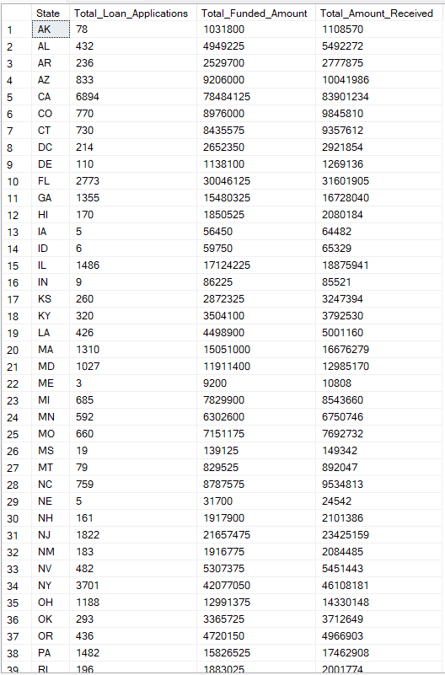

**TERM**

SELECT

term AS Term,

COUNT(id) AS Total_Loan_Applications,

SUM(loan_amount) AS Total_Funded_Amount,

SUM(total_payment) AS Total_Amount_Received

FROM bank_loan_data

GROUP BY term

ORDER BY term

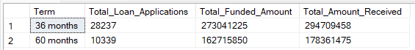

**EMPLOYEE LENGTH**

SELECT

emp_length AS Employee_Length,

COUNT(id) AS Total_Loan_Applications,

SUM(loan_amount) AS Total_Funded_Amount,

SUM(total_payment) AS Total_Amount_Received

FROM bank_loan_data

GROUP BY emp_length

ORDER BY emp_length

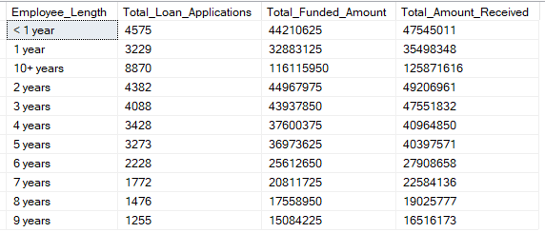

**PURPOSE**

SELECT

purpose AS PURPOSE,

COUNT(id) AS Total_Loan_Applications,

SUM(loan_amount) AS Total_Funded_Amount,

SUM(total_payment) AS Total_Amount_Received

FROM bank_loan_data

GROUP BY purpose

ORDER BY purpose

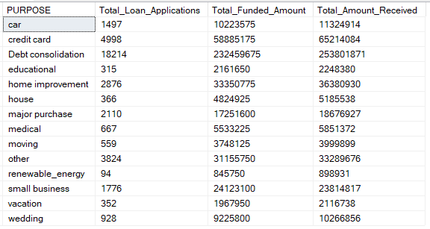

**HOME OWNERSHIP**

SELECT

home_ownership AS Home_Ownership,

COUNT(id) AS Total_Loan_Applications,

SUM(loan_amount) AS Total_Funded_Amount,

SUM(total_payment) AS Total_Amount_Received

FROM bank_loan_data

GROUP BY home_ownership

ORDER BY home_ownership

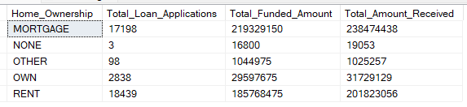

*Note: We have applied multiple Filters on all the dashboards. You can check the results for the filters as well by modifying the query and comparing the results.*

*For e.g*

*See the results when we hit the Grade A in the filters for dashboards.*

*SELECT*

*purpose AS PURPOSE,*

*COUNT(id) AS Total_Loan_Applications,*

*SUM(loan_amount) AS Total_Funded_Amount,*

*SUM(total_payment) AS Total_Amount_Received*

*FROM bank_loan_data*

*WHERE grade = 'A'*

*GROUP BY purpose*

*ORDER BY purpose*